Name = Siddhi Vishal Patil

Div.= CS3

Roll NO. = 40

PRN = 202401040152

Video link = <https://preskilet.com/siddhipatil35328@gmail.com>

## CISCO Certificate

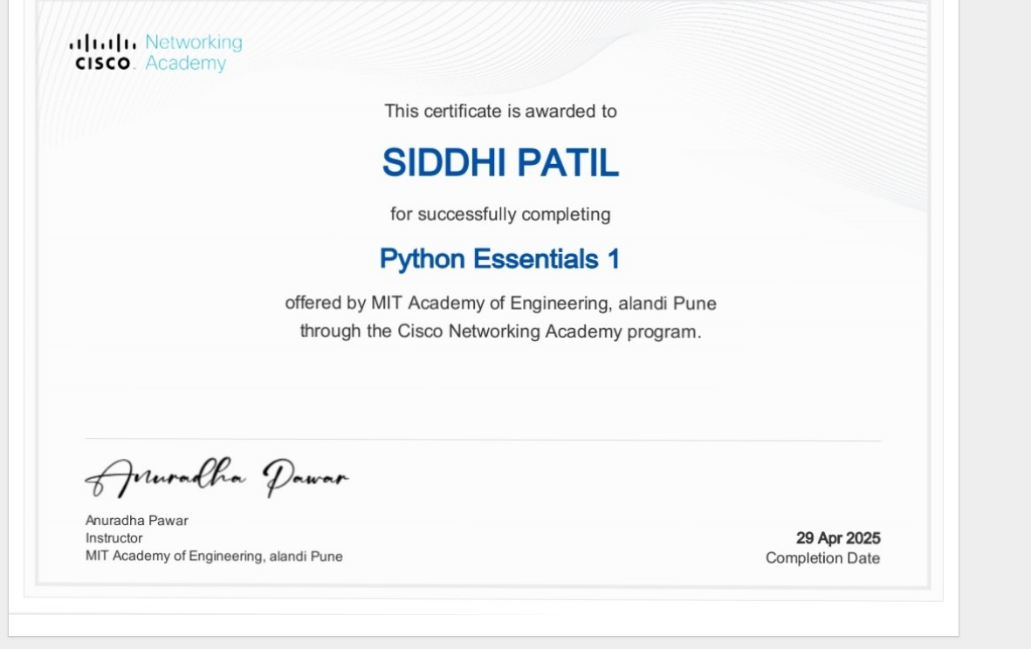

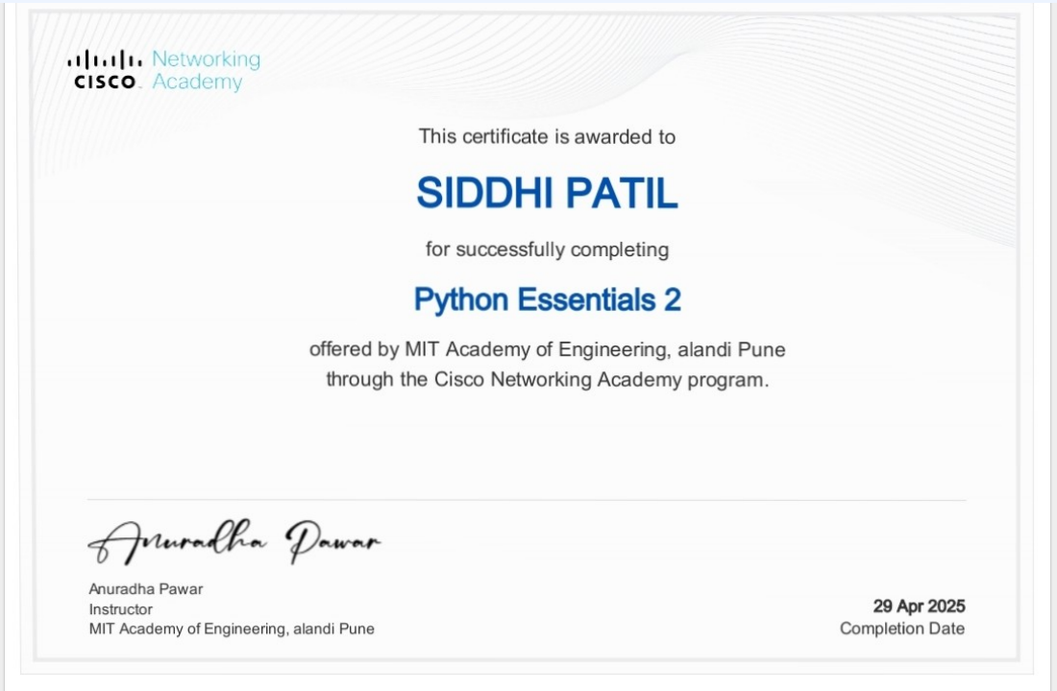

Lab Compilation

